Ignasi Arranz, Bertrand Fournier, Nigel P. Lester, Brian J. Shuter, and Pedro R. Peres-Neto. Species compositions mediate biomass conservation: the case of lake fish communities. Ecology.

Appendix S13. The effects of individual species and species compositions on biomass conservation

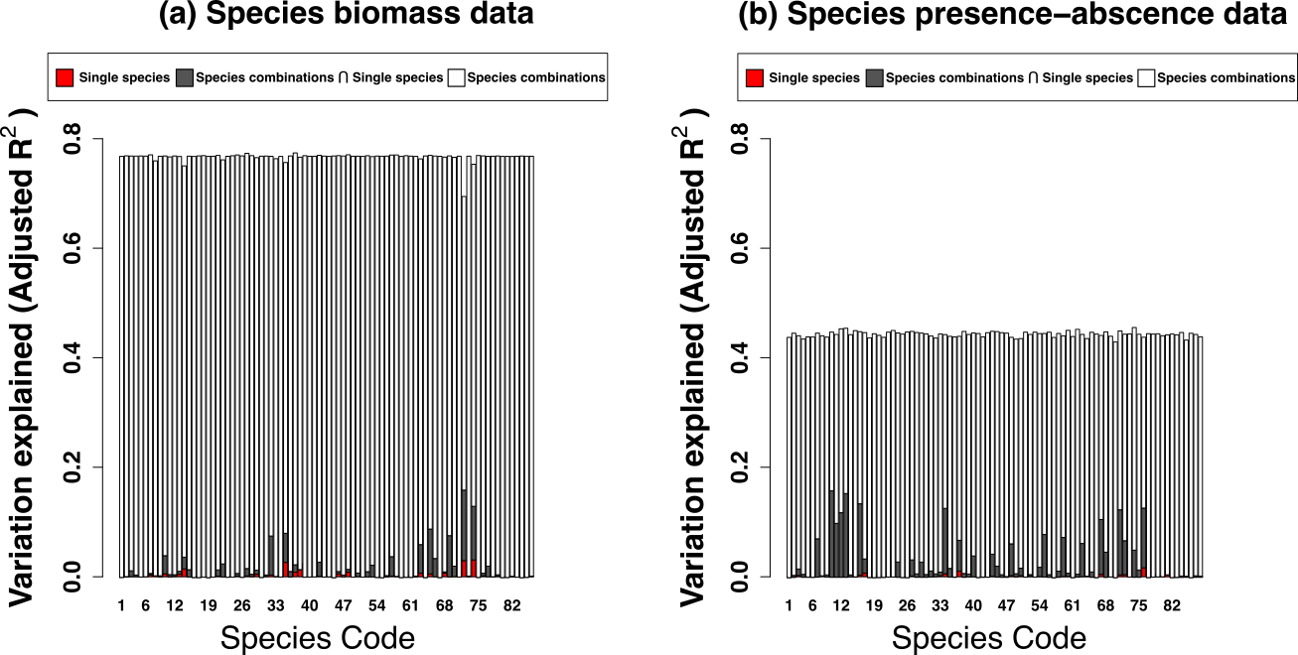

**Figure S1.** Bar plots showing the partitioning of variation in biomass conservation explained by 82 separate analyses, 1 for each unique species in the data set. In each analysis, species combination metrics are calculated with the target species omitted and associations with biomass conservation are evaluated using this reduced measure of species compositions along with data specific to the target species. (a) species compositions represented by biomass data, (b) species compositions represented by presence-absence data. Species compositions (white bars): independent effect of species compositions on biomass conservation. Single species (red bars): independent effect of target species on biomass conservation. Species compositions $∩$ Single species (grey bars): shared effects of species compositions and target species on biomass conservation. *Y*-axis is the variation explained (adjusted R2): the height of each bar is the adjusted R2 for the complete model; the shaded sections show the two independent contributions and the shared contribution.